Course Text Book: ‘Getting Started with Data Science’ Publisher: IBM Press; 1 edition (Dec 13 2015) Print.

Author: Murtaza Haider

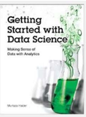

Prescribed Reading: Chapter 3 Pg. 60-62

